**User Manual for**

**Blood Bank**

**Management System**

Group : 7

Anita B230818CS anita_b230818cs@nitc.ac.in

Farheen B230299CS farheen_b230299cs@nitc.ac.in

Ardhra Alaina Winston B230198CS ardhra_b230198cs@nitc.ac.in

Gunna Mohanna Prathyusha B230324CS gunna_b230324cs@nitc.ac.in

Kolassani Maithilli B230385CS kolassani_b230385cs@nitc.ac.in

**Instructor:** Pranesh Das

**Course:** Database Management System

**Date:** 31-03-2025

**Table Of Contents**

**Registration and Login**--------------------------------------------------------------------------------- 1

Registration--------------------------------------------------------------------------------------------- 1

Login-------------------------------------------------------------------------------------------------------3

**DashBoard Page for users**--------------------------------------------------------------------------- 4

Overview------------------------------------------------------------------------------------------------ 4

Request Blood [For Patients] ------------------------------------------------------------------------ 5

Donate Blood [For Donors] -------------------------------------------------------------------------- 6

Request and Donation History---------------------------------------------------------------------- 6

**DashBoard Page for Admins**----------------------------------------------------------------------- 8

Blood Stock---------------------------------------------------------------------------------------------- 8

User Management------------------------------------------------------------------------------------- 9

Blood Requests----------------------------------------------------------------------------------------- 11

Donate Requests--------------------------------------------------------------------------------------- 12

Donation and Request History-------------------------------------------------------------------- 13

**Profile**----------------------------------------------------------------------------------------------------- 15

**LogOut**---------------------------------------------------------------------------------------------------- 16

**Registration and Login** 1

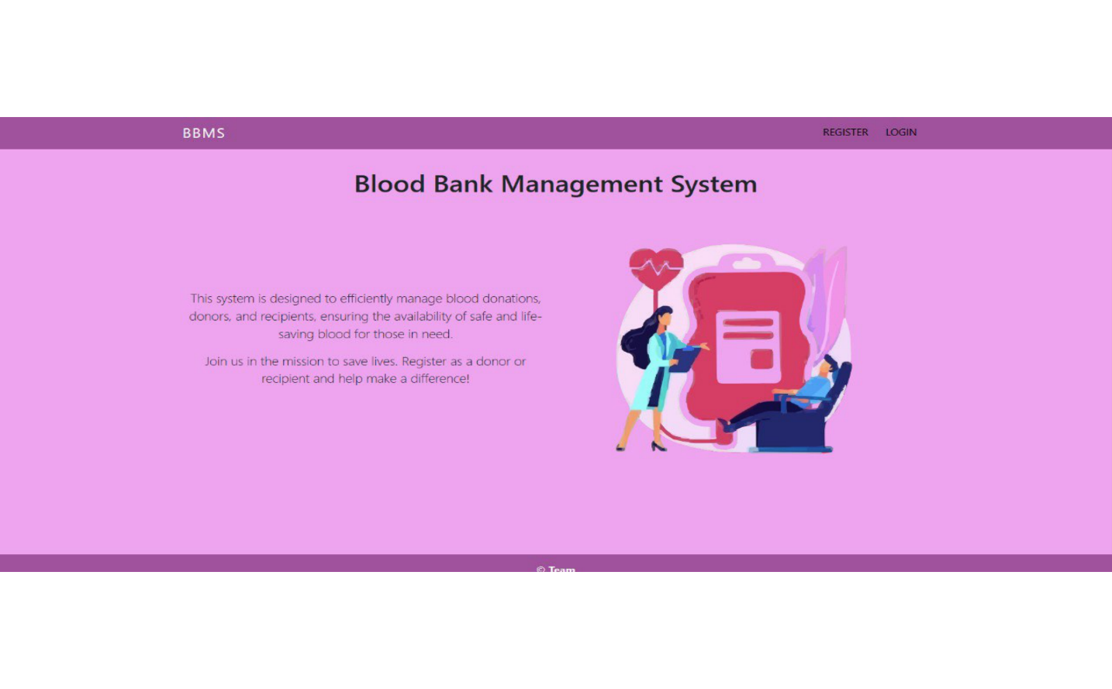The Blood Bank Management System (BBMS) Home Page serves as the initial gateway for users, presenting a welcoming interface with essential features. The navigation menu prominently displays two crucial options: Register and Login. These guide users to either initiate the registration process or access their existing accounts.

**Registration**

To get started with the BBMS, users need to create an account according to their role(patient/donor). Follow these steps to register:

● Navigate to the registration page.

● Fill in the required details such as name, email, username, and blood type.

● Choose a secure password.

● Submit the registration form.

Upon successful registration, users will be redirected to their respective dashboard page.

Note: Currently, registration as an admin is not allowed for security purposes.

2

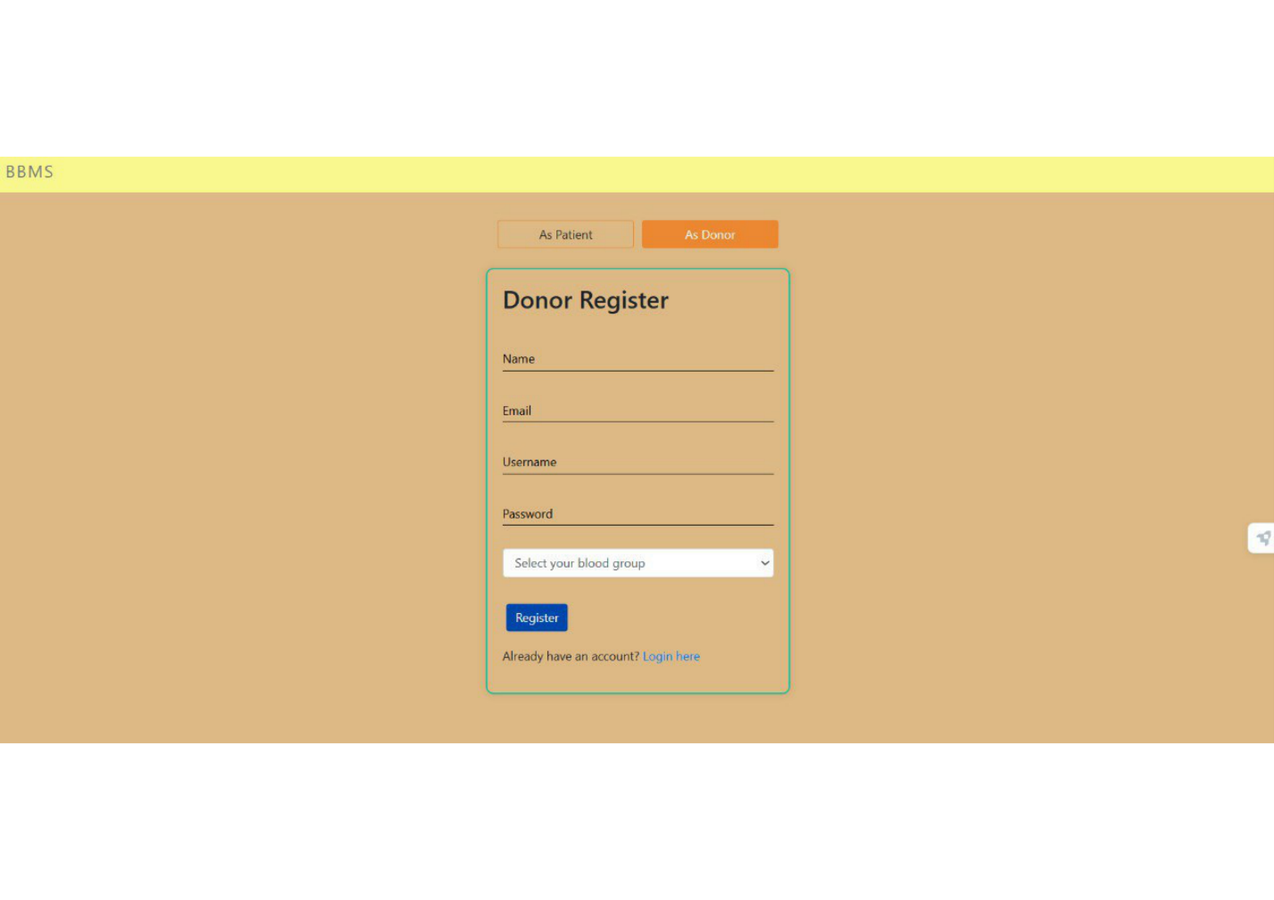

**Login 3**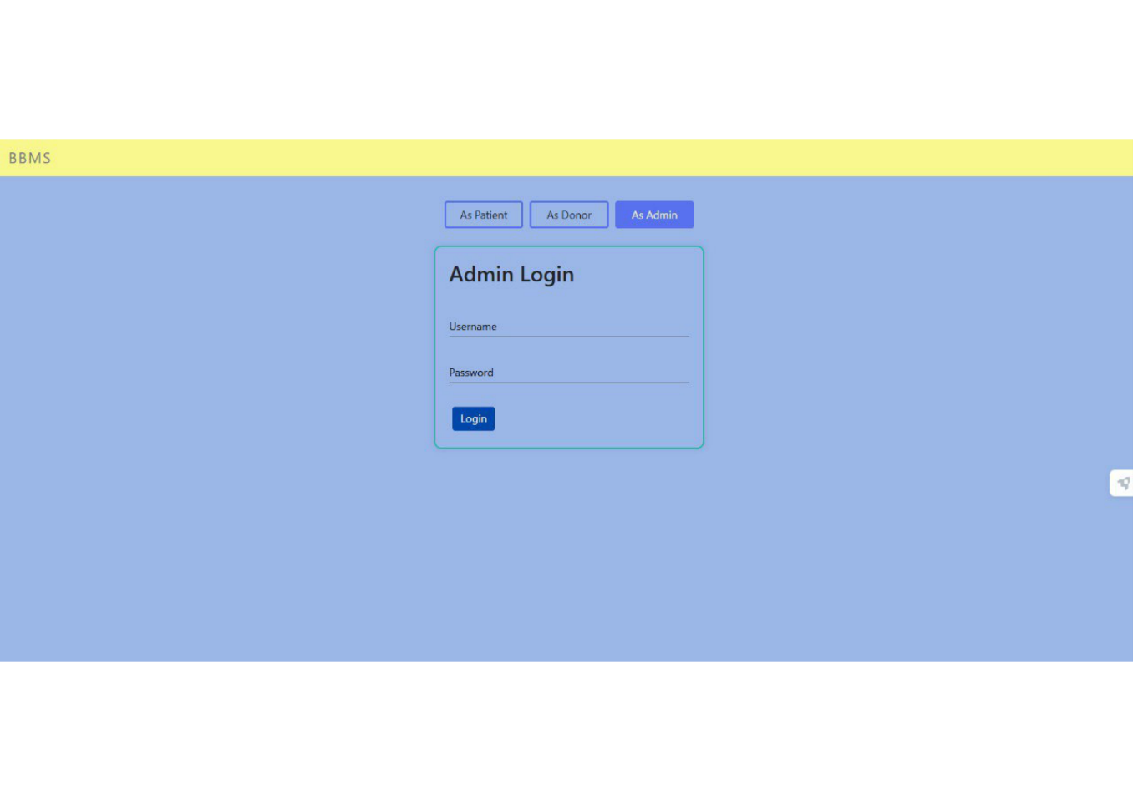

Already registered users can log in using their credentials:

● Gotothe login page.

● Enter the registered username and password.

● Click the login button. 4

If there are any errors during login/register form validation, relevant error messages will be displayed to guide the user.

Access to the user-specific dashboard will be granted upon successful login.

**DashBoard Page for users**

**Overview**

Upon successful login, users are directed to their personalized Dashboard, tailored to their specific roles as either patients or donors. The dashboard provides a streamlined and user-friendly interface with distinct features based on their roles.

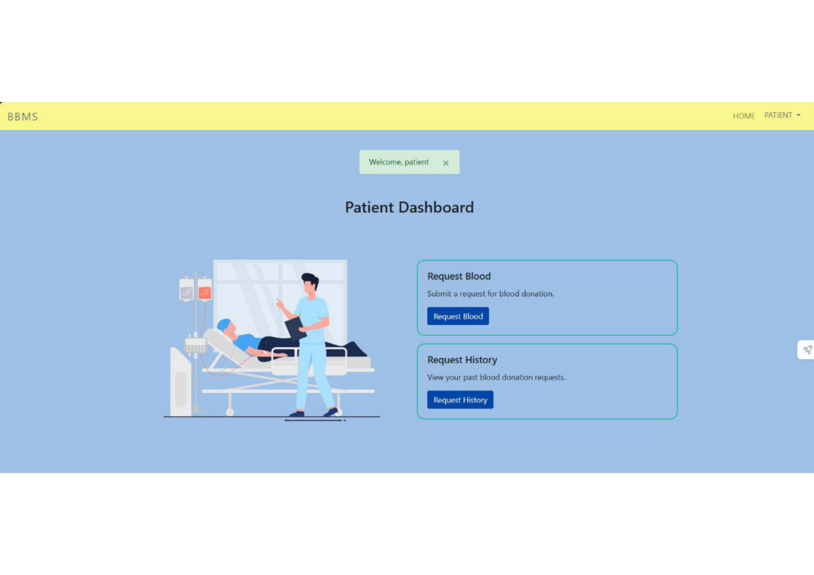

5

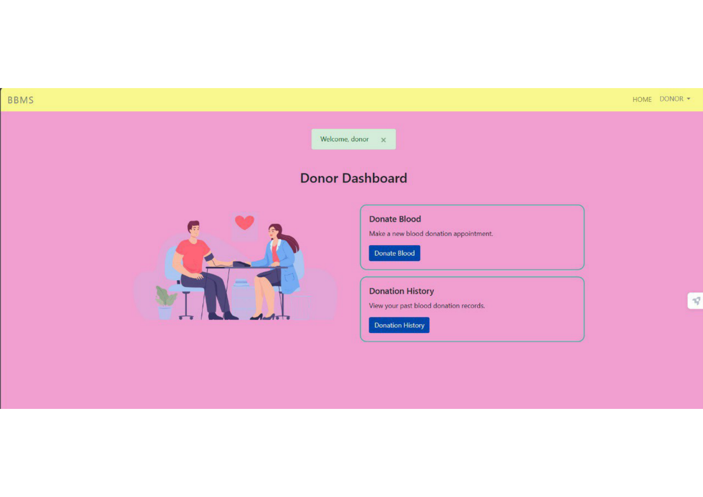**Request Blood [For Patients]**

Patients can submit requests for blood, specifying their blood type and urgency. Submitted requests are directed to the Admin Dashboard, allowing administrators to assess the urgency and blood type against the current blood stock.

6

**Donate Blood [For Donors]**

Donors can easily schedule blood donation appointments, providing essential health information. The system forwards this data to the Admin Dashboard for review. Admins assess the details, approving or rejecting based on health considerations.

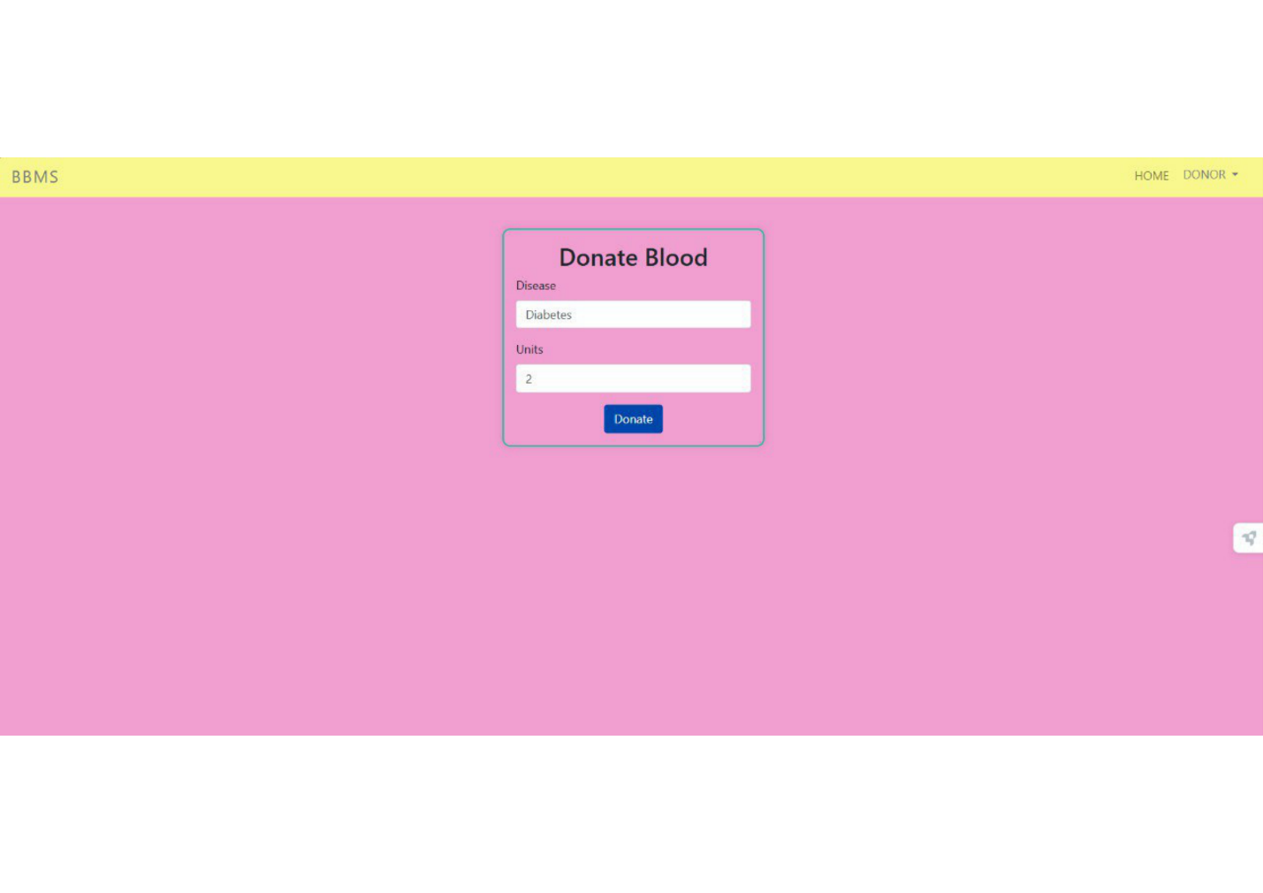**Request and Donation History**

Users can access a consolidated history of their blood-related activities.

For patients, this includes reviewing past blood requests with status and details.

7

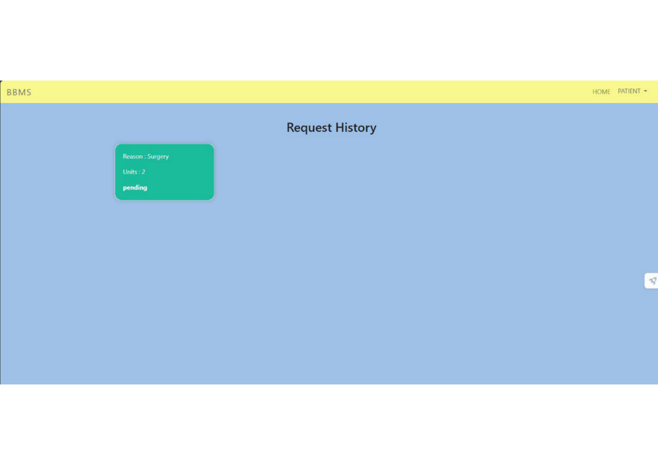Donors can track their donation history, viewing the status and details of each contribution.

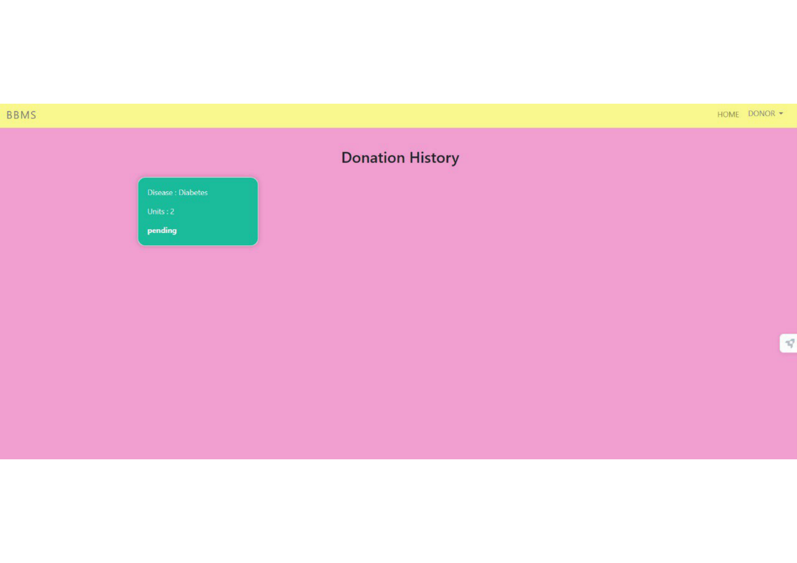

The user-centric dashboard is designed to cater to the specific needs and actions associated with each role, providing a seamless and intuitive experience.

**DashBoard Page for Admins**

The Admin Dashboard serves as a control center for efficient blood management.

**Blood Stock**

Admins can monitor the quantity of each blood type available, enabling proactive stock management. Easily update and manage blood stock to meet demand.

9

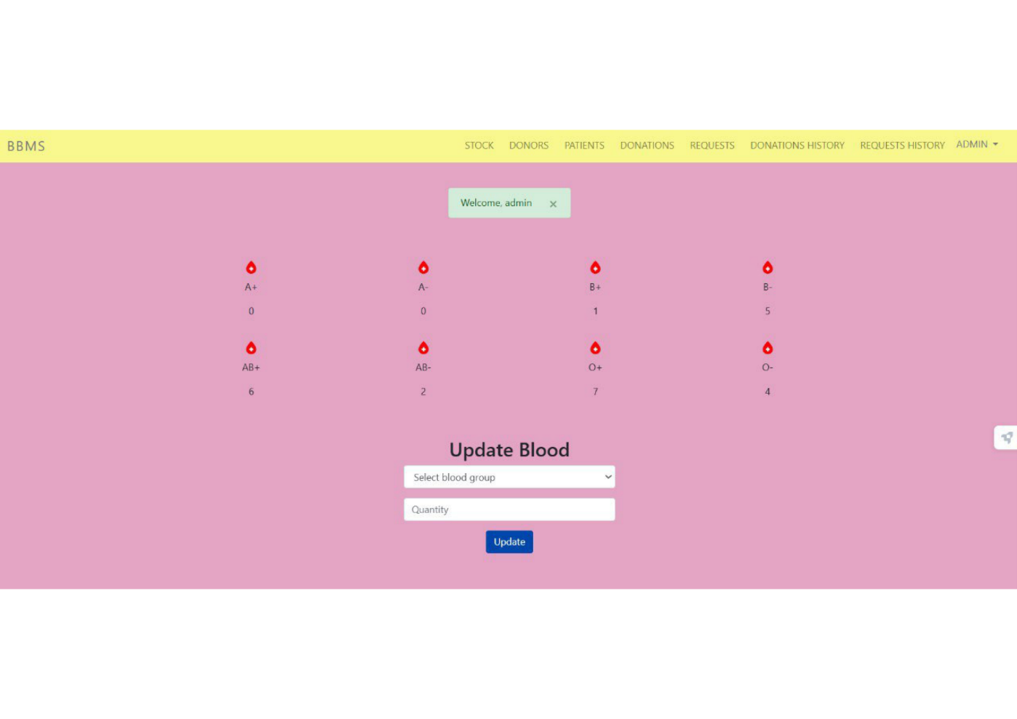

**UserManagement**

Review the list of registered blood donors and patients. View patient information as well as donor profiles.

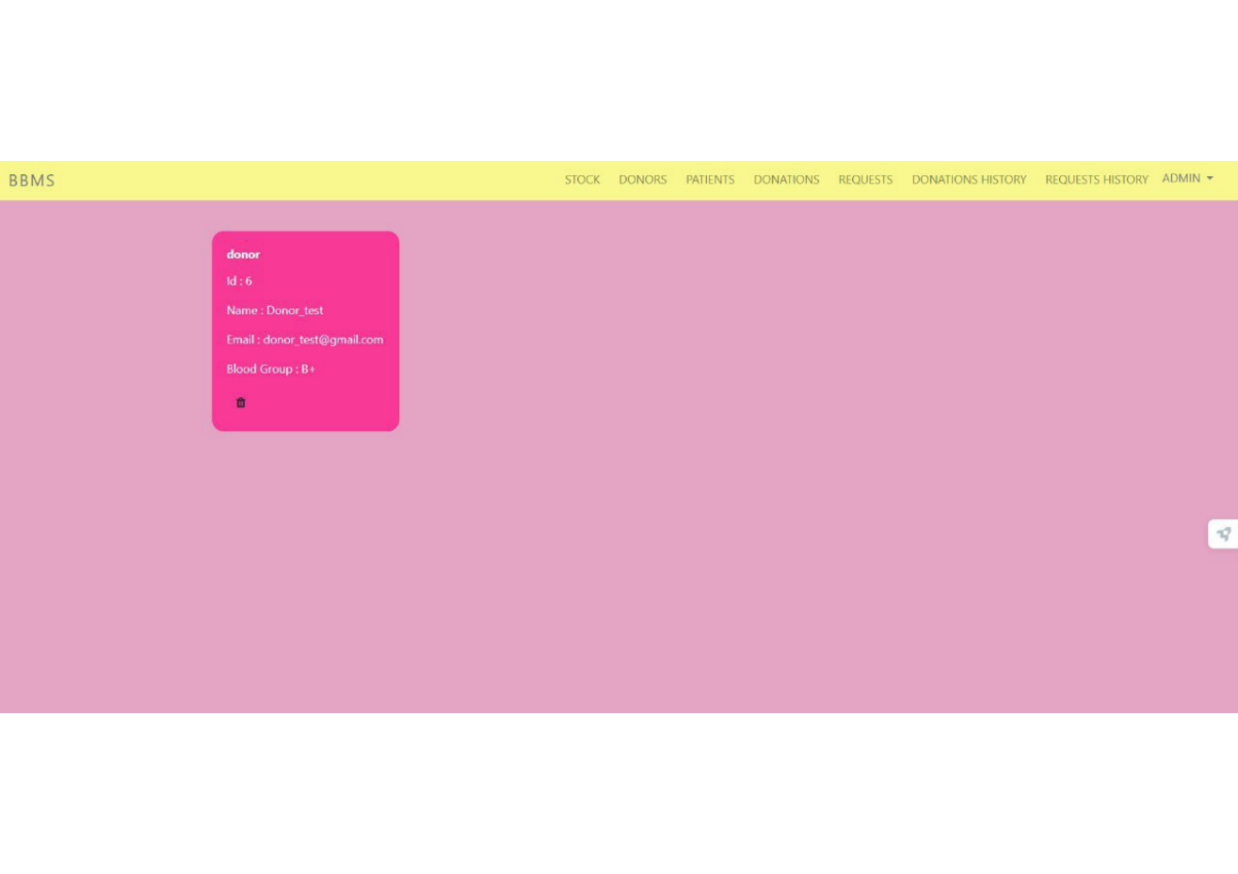

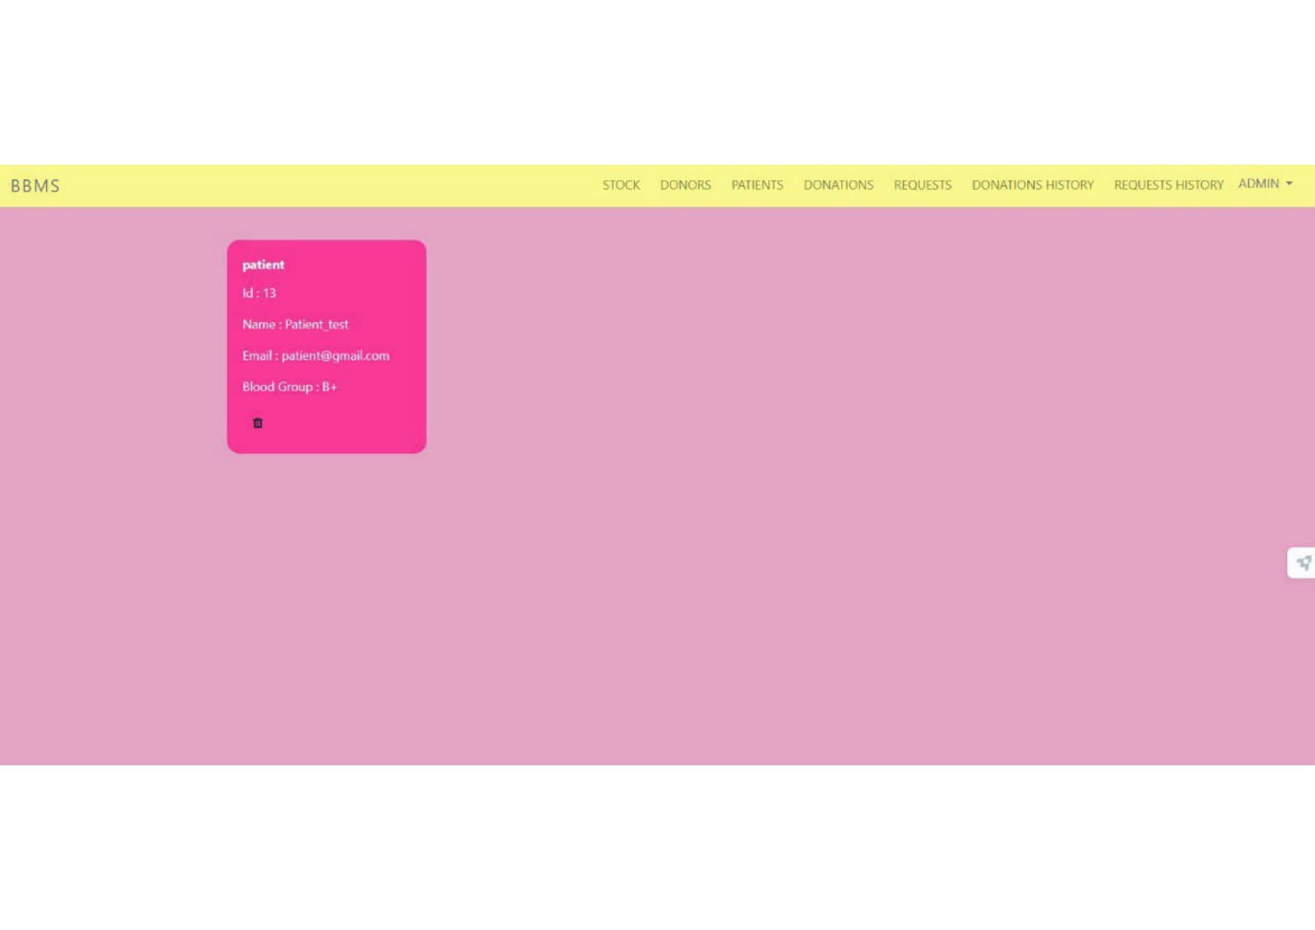

11

**Blood Requests**

View all pending blood requests. Access specifics of each request, aiding in efficient approval or rejection.

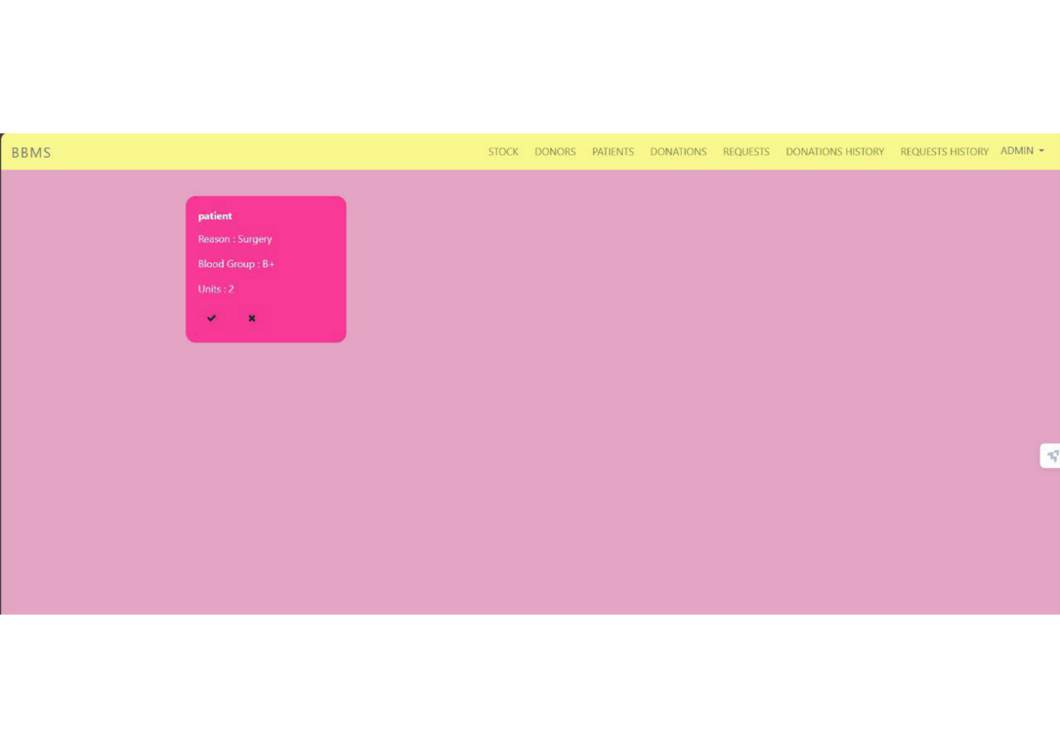 12

**Donate Requests**

Admins can click on donation requests to access specific details of each request. Specifics include information about the donor, blood type, quantity, and any additional notes provided by the donor.

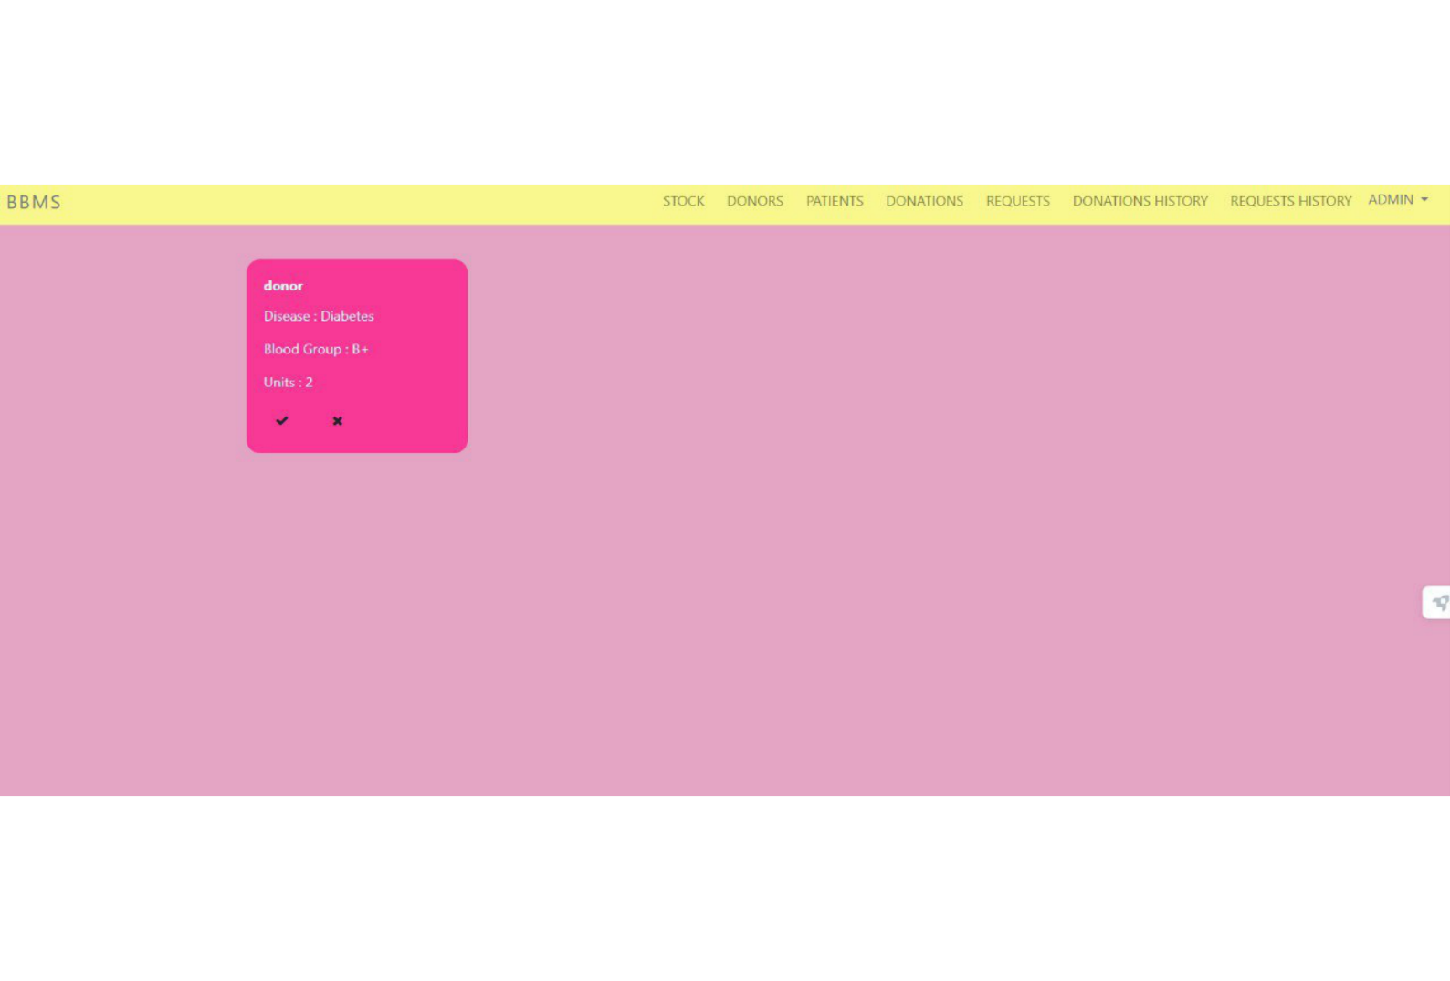

13

**Donation and Request History**

Admins can track the history of all blood donations, including the status and details of each donation.

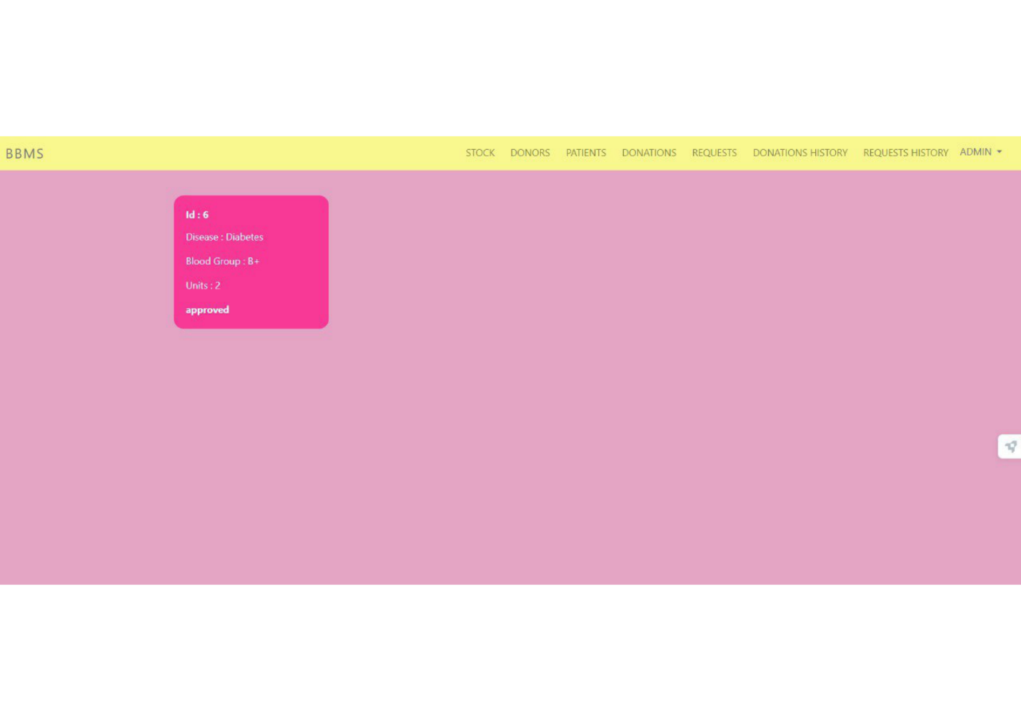

Admins can review the history of all previous blood requests, including the status and details of each request.

14

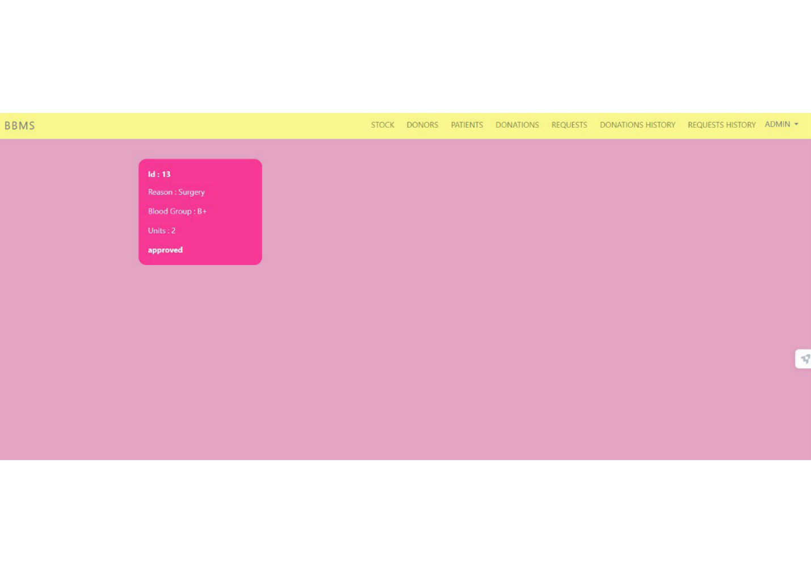This detailed breakdown empowers admins with granular control over blood-related processes, fostering an organized and responsive system.

15

**Profile**

Access and manage personal profile information, ensuring accurate and up-to-date details for efficient communication.

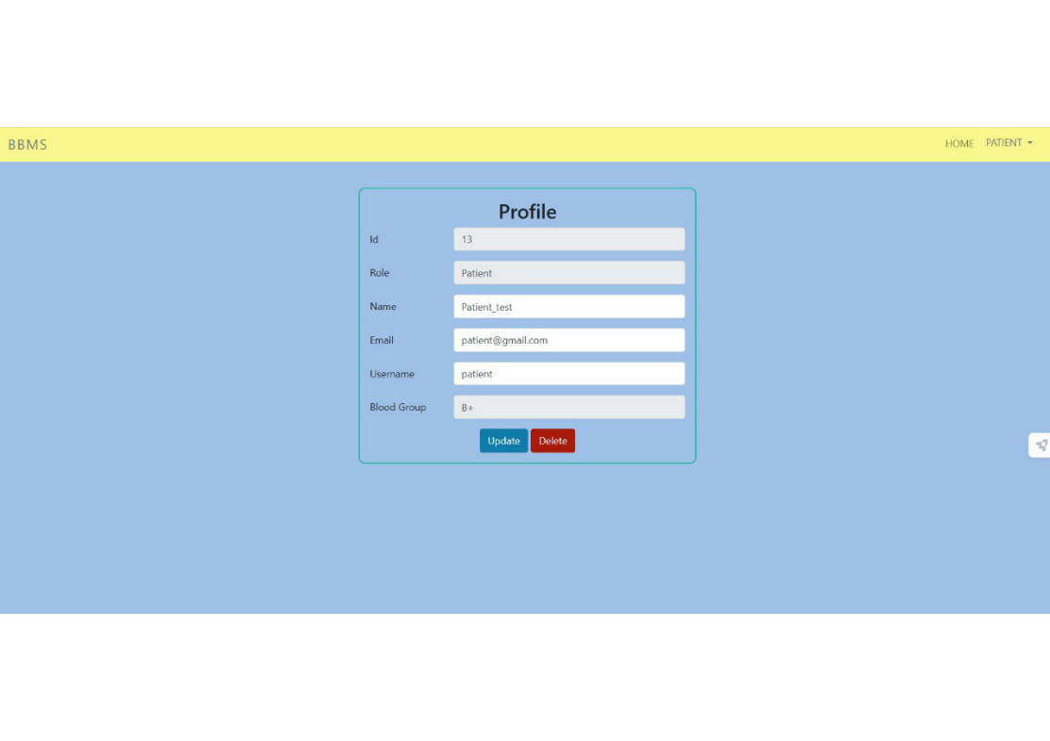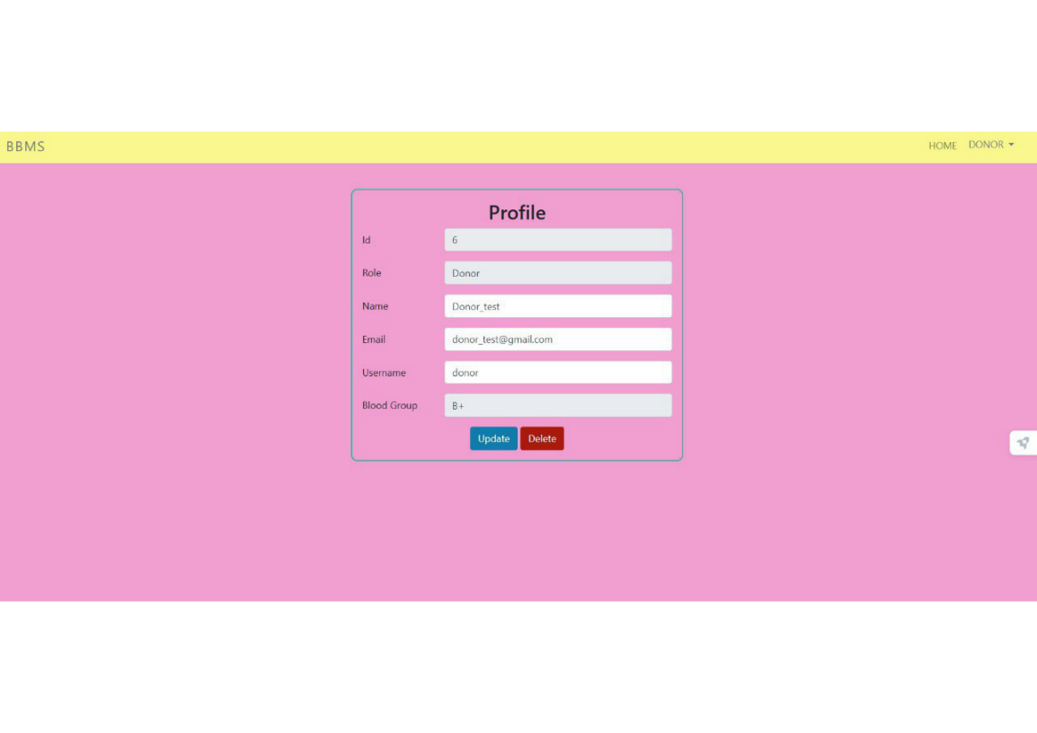

16

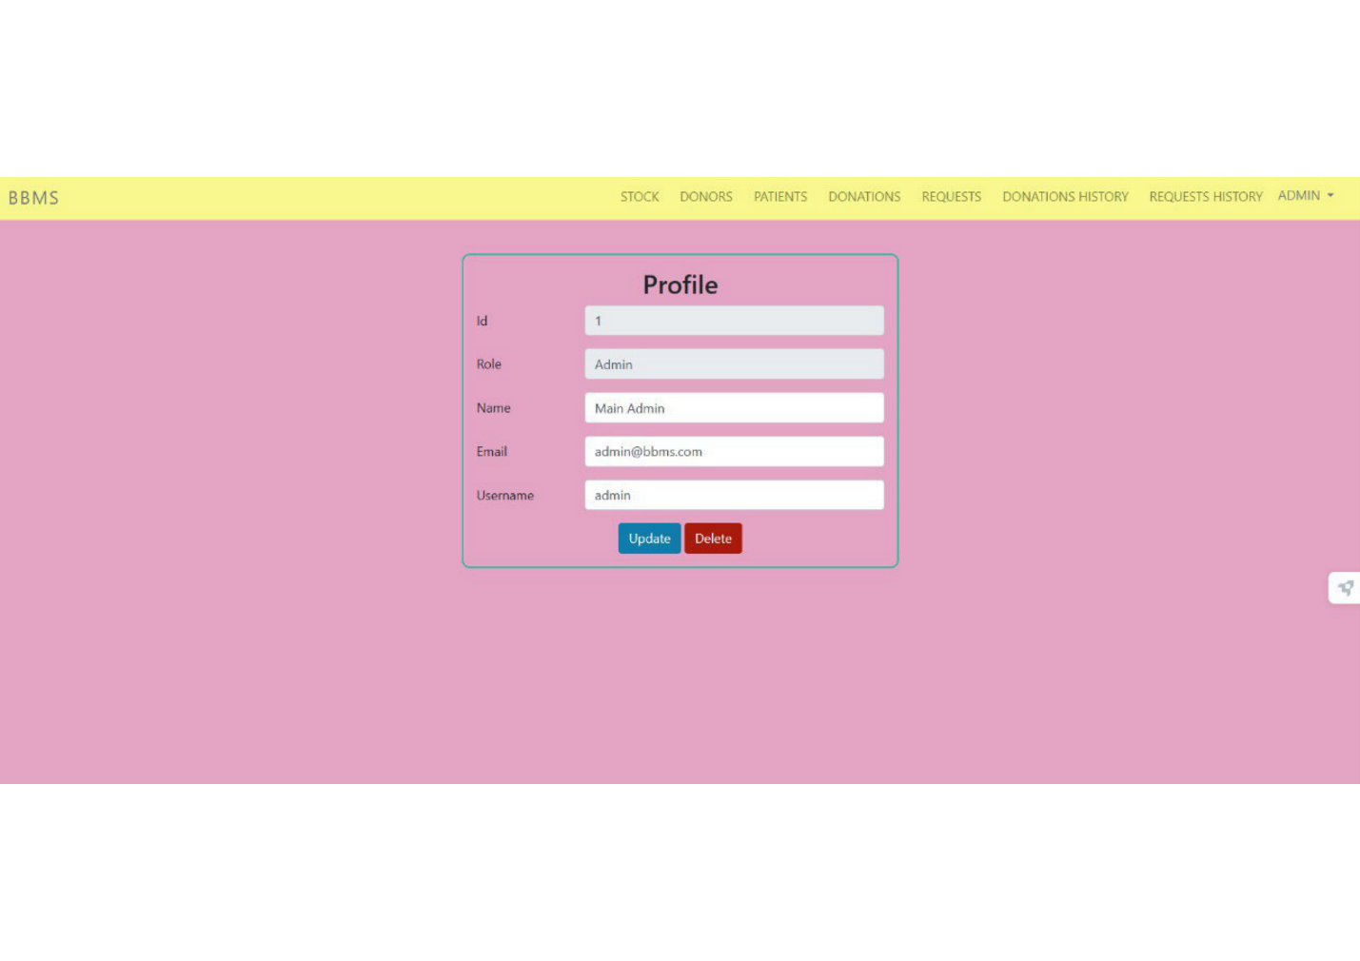**LogOut**

To log out from BBMS, simply click on the Logout button located in the top right-hand corner of the page. This action will securely end your session and redirect you to the BBMS home page